Architecture and Design Document

Table of Contents

**Diagrams**

* **System Diagrams and Component Diagrams**
* **Use Case Diagram**
* **Activity Diagram**
* **Sequence Diagram**
* **Class Diagram**
* **Entity Relationship Diagrams**

**Analysis**

* **Trade off Analysis**
* **Machine Learning Analysis**

**Diagrams**

**System Diagrams**

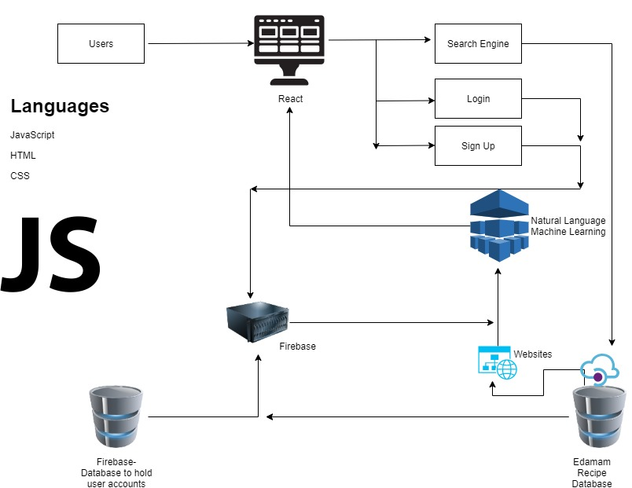

**Component Diagrams**

**Use Case Diagrams**

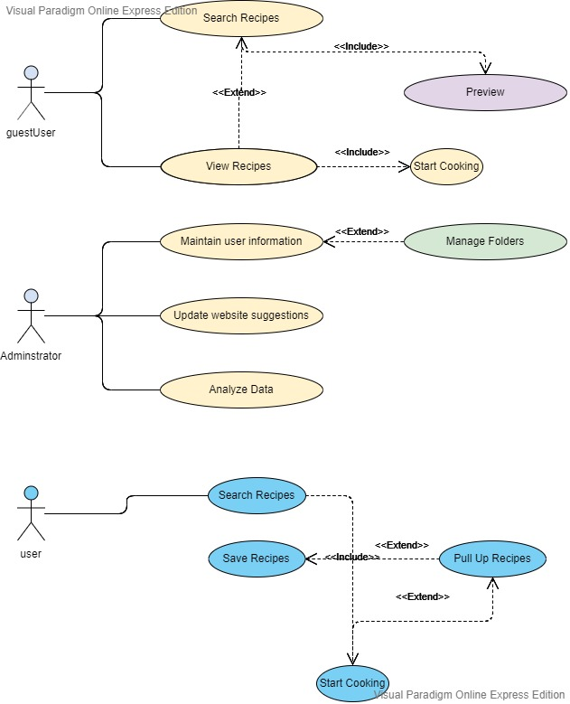

**Activity Diagrams**

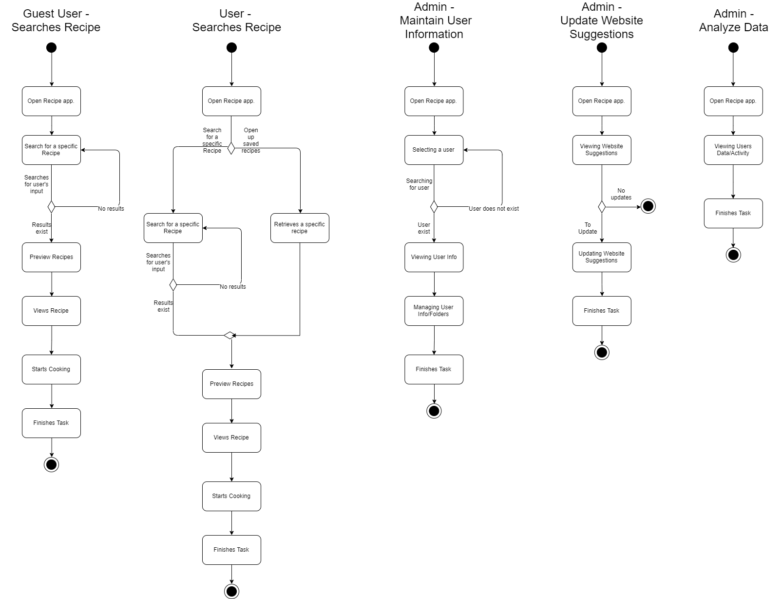

**Sequence Diagrams**

**Class Diagram**

**Entity Relationship Diagram**

**Analysis**

**Trade-Off Analysis**

The Client-Sever Architectural Design was chosen as the architecture for the project. MVVM and MVC were other patterns considered for the project.

**Machine Learning Analysis**